ReStore Silent Auction Marketing Plan
Fundraising Event: Silent Auction
Where: West Aurora ReStore (Grand Reopening) 2302 W. Indian Trail Rd.
Dates: April 16 & 17
Time: Fri. Ends at 2:30 & Sat. Ends at 2:00
Part of the store being auctioned: Fri. Decor and Appliance side Sat. Furniture side
Why: April 16th and 17th will be our grand reopening and will hopefully generate a lot of foot traffic in our doors. If we hold a silent auction during our grand reopening, this will allow people to be able to bid on items they want and try to outbid each other. As we will likely have more people in the door than usual we can have a designated section for only items that will be auctioned off. Bidders will have a chance to bid on their desired items during the allotted time with an option to buy now at a predetermined price above the listed or retail price. Starting price should be 50% to 60% the regular ReStore price. All of the money that we make from the bids will go directly towards the families and allow us to generate funds to help with the construction of their future homes. If a bidder wants to buy an item before the time expires they will have to pay above the listed price to ensure a profit. We can have the decor and appliance section of the store be auctioned on Friday and the furniture side be auctioned on Saturday. If we created a designated pathway with a safe amount of distance between items and limit the number of people who can view an item at once, then we can hold this event while following COVID guidelines.
There should be some means of registration for the event to ensure that it will run as smoothly as possible. Before running the silent auction, we should have a pre-registration link to assign their auction number, obtain their name, email, what they would most likely buy from us, the date they are attending, and a phone number. There can also be a registration booth on the day of the events to assign bidding numbers to people. If an entry fee is possible we should implement one to ensure that there is more money being donated no matter what the items are sold at and to easily account for the items being auctioned for the registered bidders. The information they give us will allow us to assign them a bidder number to place on the bidding sheets, obtain their email for marketing purposes, predetermine items to auction off for each day, and receive their contact information for future reference. This registration will allow us to have an estimate of how many people will be in attendance and plan accordingly. There should also be a minimum incremental price to increase a bid. If an item is lower-priced, the incremental price should be about $1, but if the item is more expensive the minimum incremental price should be around $5. If we have an entry fee, there should also be a raise in the entry fee to become a bidder on the day of to incentivize early registration. We should also try to hire volunteers beforehand for the dates to help run the auction smoother.
A couple of days before the Reopening and the Women’s Night we should set aside items in the back and a designated area to put the items so we have a clear path for the bidders to follow. There should be a circle-like formation or an easy way for bidders to navigate to and from each auction item. There should be a one-way path so bidders do not come into close contact with each other. The auction items should be positioned from least expensive at the beginning to most expensive at the end. This is done so the bidders still have money to be able to place bids at the end of the path. Each auction item should have a bidding sheet, an item description, a market or retail price to compare it to, the incremental price minimum, and a buy now price. If the buy now price and the retail price are priced high this uses the anchoring effect so that people value something closer to the numbers they have been given. Bidders should bid with their bidding number rather than their name to remain anonymous. There should be about one item for every two people, but too many items can be overwhelming. The highest bid at the end of the closing time or purchasing at the buy now price wins the item being auctioned off. The item descriptions should note what the item is, why it’s valuable, and any product defects. The bidding sheet should have the bidder number, the minimum listed price, and the current bidding price. Setting all of these things up beforehand will allow the event to go smoother.
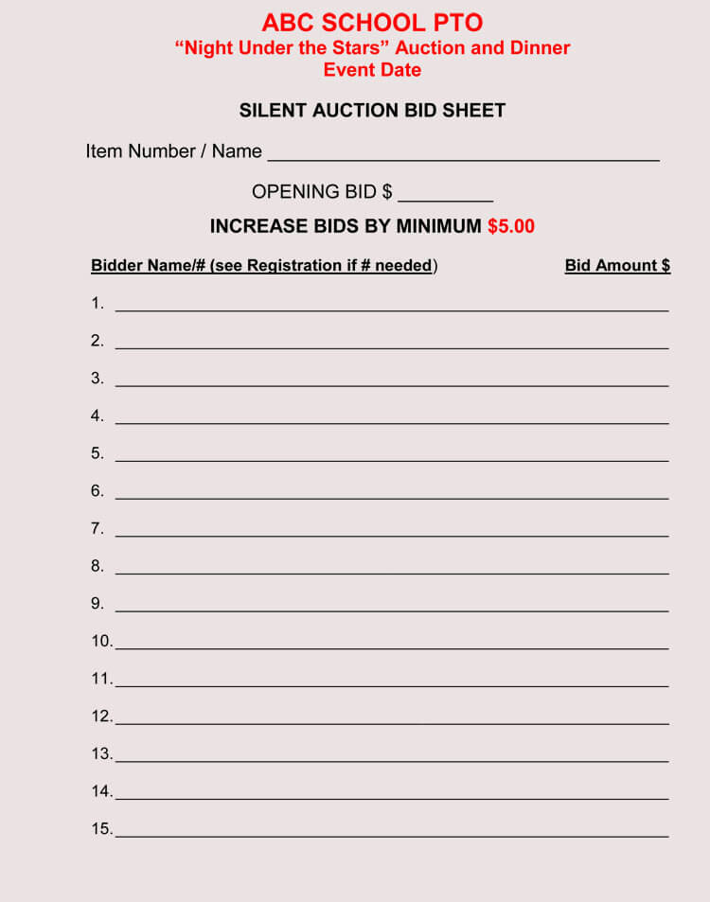
Sample of bidding sheet
While the auction is being held there should be some rules and regulations to help run the auction better. The items should all be arranged so they are all easily visible. There should be a sign signifying that all sales are final with no exchanges or refunds. Items should also have something saying that that they are sold as-is. People must increase their bid by at least the incremental bid and if they do not their bid is invalid and should be crossed off. Anyone who has not paid the entry fee will not be able to participate in the auction at all. They must show their bidder number and be signed in before entering the auction. For their bid to be valid they must sign their bidder number clearly and meet the incremental minimum for the desired item. If they want to buy an item now they must signal to one of the auction overseers to end the bid for that item. There should only be a limit of 2-3 people that can view an item at once to avoid congestion. The traffic should only be directed in one direction and if they want to back to the beginning they have to move out of the end and to the beginning again. This will prevent people from going back to whichever auction item they want to and causing a traffic jam. Once the auction time has finished, there will be no more bids and the highest bidder wins the item.
Once the auction ends there will be a 15-30 min grace period before reporting to the cashiers to determine winners and link any orders with multiple winning bids. Bidders should be notified of the time remaining so they can place their final bids before the auction closing time. We should make copies of all the bidding sheets for reference of which bidder won. Winning bidders must show a paid receipt or proof of purchase to pick up their items. Winners should be called down to the cashier or contacted via their phone or email if they left before picking up their items. If there has been a certain amount of time after the bidder has won and they haven’t redeemed their bid the next highest bidder should be contacted to see if they still want the item for their last bid. All the sold items should be marked as sold and sent to the cash register with any items that have been won by the same bidder. All the money being raised from the silent auction will be separated or written down to keep track of the profits made from the fundraiser. Hopefully, this event will be very profitable due to all of the attractions being held at the event.
If someone does not want to participate in the auction but would still like to help out with future builds we can also hold a 50/50 raffle. Similar to the raffles that the organization has held in the past half of the earnings can go to the winner of the raffle and the other half will go to future builds. This raffle can be held as more of a supplement for someone who doesn’t want to or cannot participate in the auction. One 50/50 raffle could be held per day on the event dates including the women’s night to keep from getting confused with the earnings from the different dates. Another thing that we could do to get more profit would be to raffle or auction off a car, similar to the raffle at the first grand opening of the ReStore. If we can manage to receive another donor this raffle will likely be successful and will also serve as a supplement to the silent raffle, but this raffle might be harder to accomplish seeing as the last car raffle was a gift specifically for the opening.
This event could be very successful if it is executed well. Following this plan will help the execution of the event as most of these tips and rules have worked for many silent auctions that have been held in the past. There has to be a little bit of planning and setting up before the event, but most of this stuff is manageable and will benefit us in the long run. Some of the logistics still have to be figured out such as what will be auctioned off and what the entry fee should cost, but once these factors have been decided this will be something that will be a great addition to the Grand Reopening of the ReStore. This auction will help complement any other attractions we have at the reopening and will help spread the word about the reopening. The sooner we start to plan and promote this auction the smoother it will run on the actual days of the event. This is also something that can be tested out on the Women’s Night the night before the reopening and allow us to tweak our rules if needed. This auction will not only benefit the organization but will hopefully help fund the future builds that are being planned.
